**SPRING BOOT PROJECTS**

Spring is a comprehensive framework for enterprise Java development. It provides a wide range of tools and features to build applications efficiently, focusing on aspects like dependency injection, aspect-oriented programming, and transaction management.

Spring Boot is an **opinionated extension of Spring** that simplifies the development process by reducing the amount of configuration required. It allows you to build Spring applications quickly, focusing on application logic rather than setup.

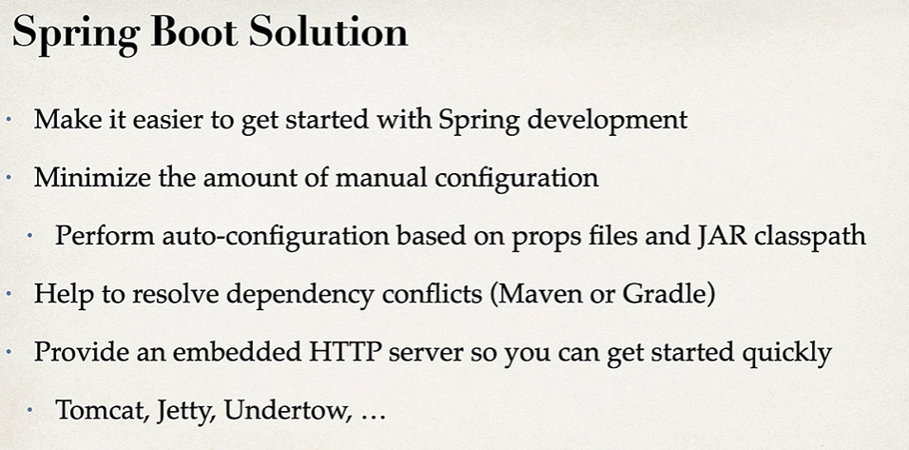

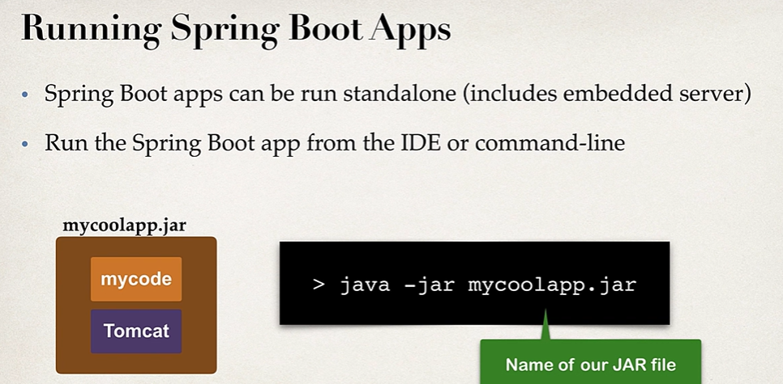

**What Are JAR Files?**

A **JAR (Java ARchive)** file is a compressed file format used to package **Java classes, metadata, and resources** into a single file. It is based on the ZIP file format and is primarily used for **distributing Java applications** or libraries.

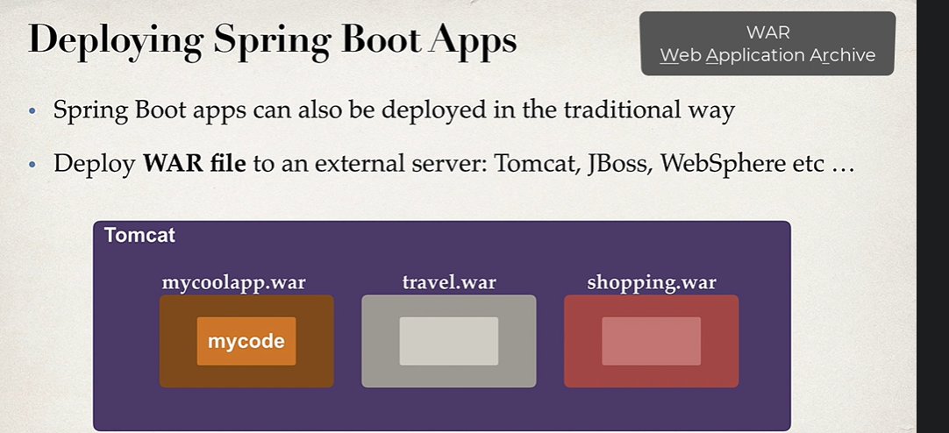

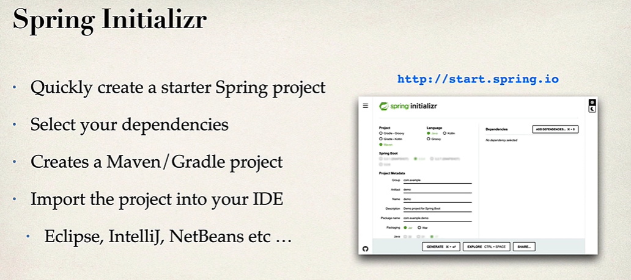

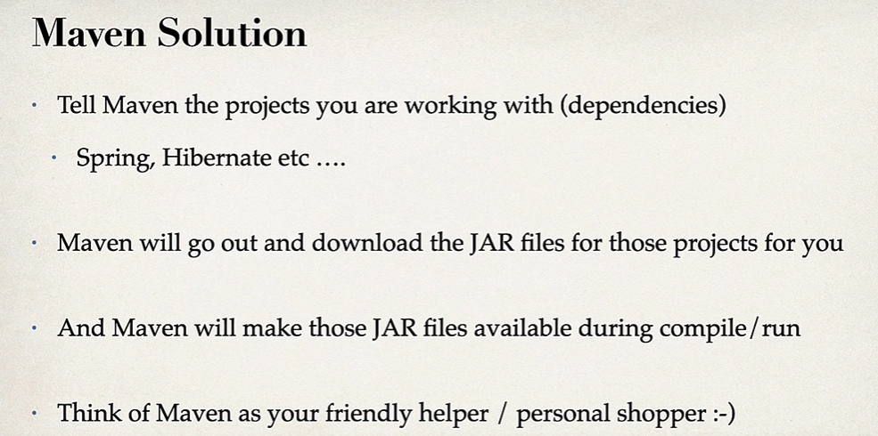

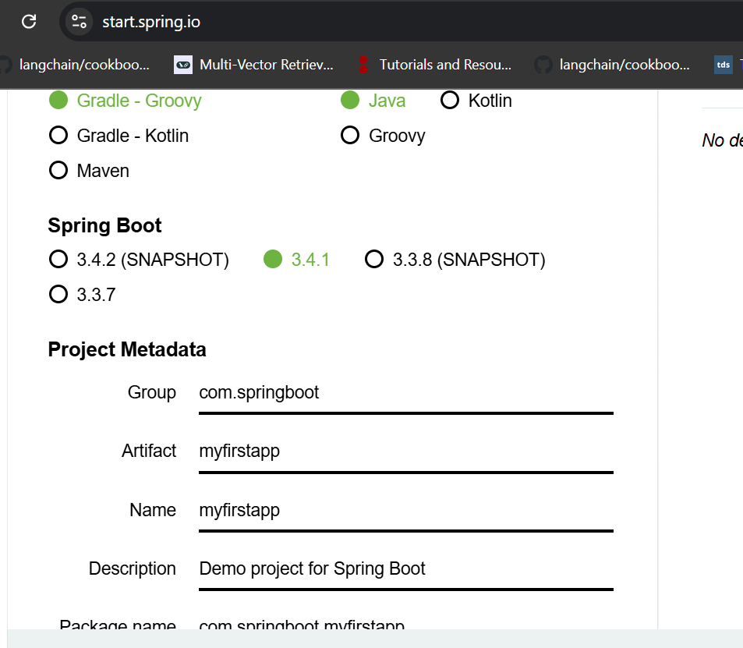

Choose maven.

Add spring web dependency and whatever dependency is needed

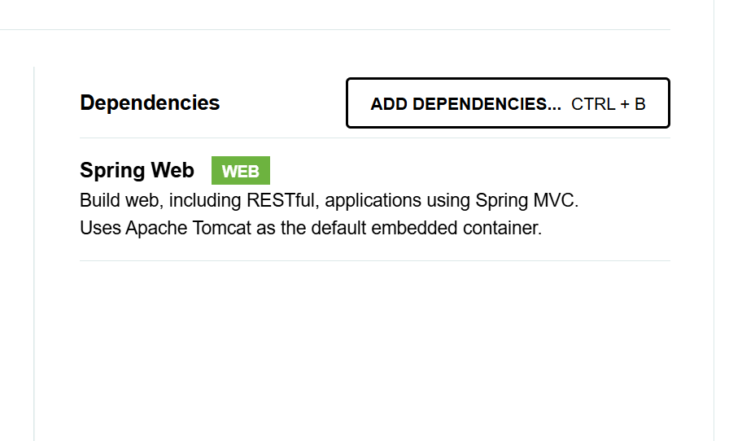

**Apache Tomcat** is an open-source web server and servlet container developed by the **Apache Software Foundation**. It is specifically designed to execute Java-based web applications that use **Java Servlets**, **JavaServer Pages (JSP)**, and other Java-based web technologies.

Tomcat is widely used for deploying and running **Java EE (Enterprise Edition)** web applications. It serves as a lightweight alternative to full-stack application servers like WildFly or GlassFish.

**REST Controller**

A **REST controller** is a component in a software application, typically implemented in frameworks like **Spring MVC** (Java), **Flask** (Python), or **Django** (Python), that handles HTTP requests in a **RESTful (Representational State Transfer)** architecture.

RESTful services are stateless, meaning the server does not retain any client session information between requests. Each request must contain all necessary information.

A REST controller primarily handles the HTTP layer and delegates the business logic to a separate service layer.

**GRADLE AND MAVEN**

**Gradle** and **Maven** are both **build automation tools** used primarily for managing dependencies, compiling code, running tests, and packaging applications. They are essential in Java (and other JVM-based language) projects but also support a variety of other languages. These tools simplify the build process, enabling consistent and efficient management of projects.

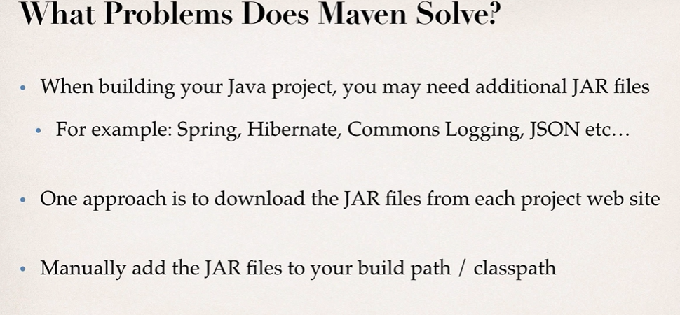

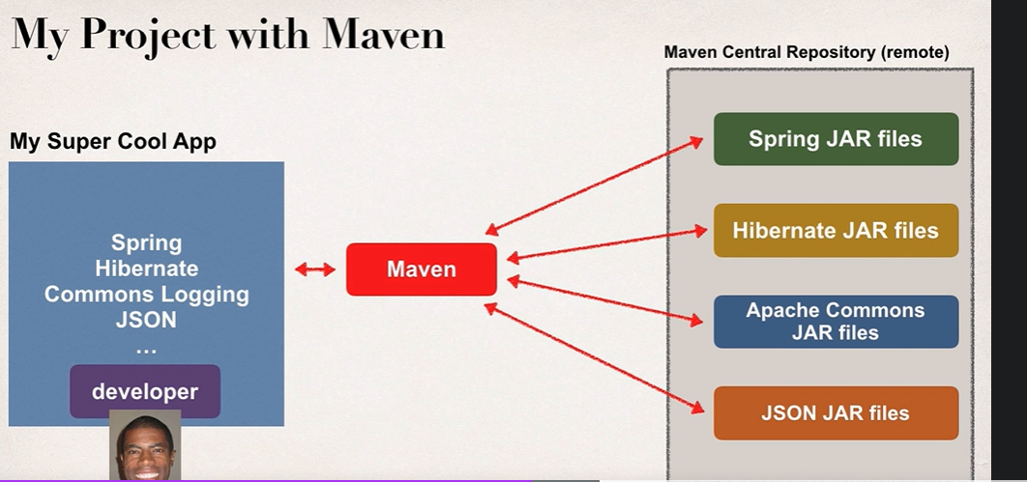

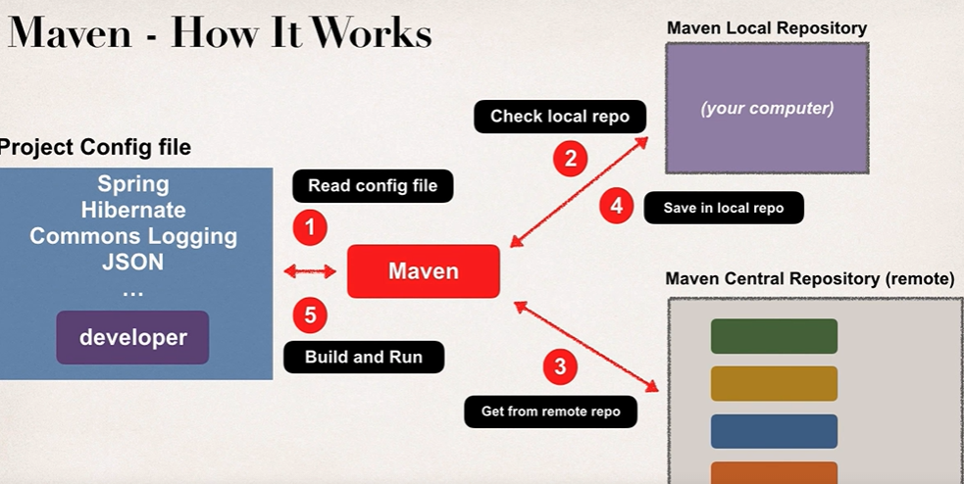

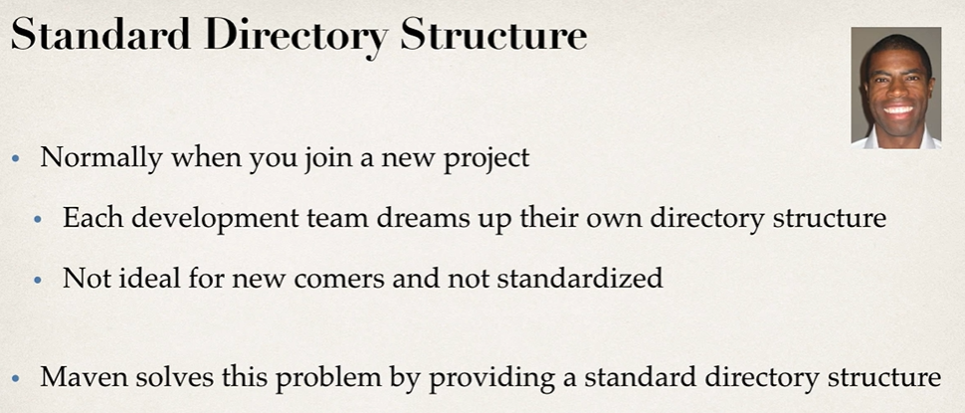

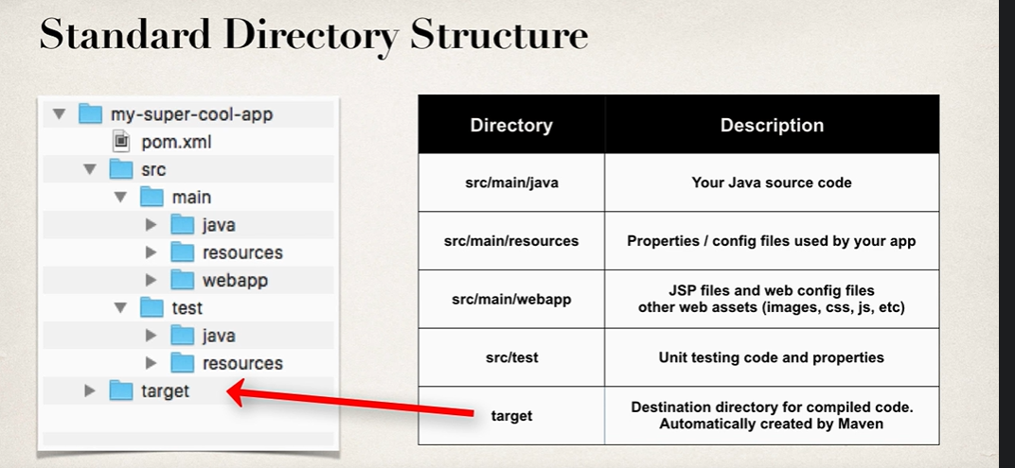

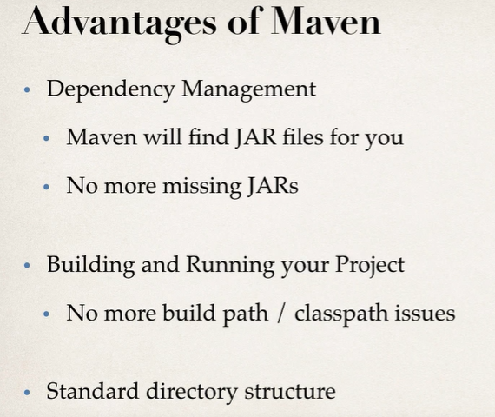

**IMPLEMENTING RESTCONTROLLER**

Set the port in application.properties:

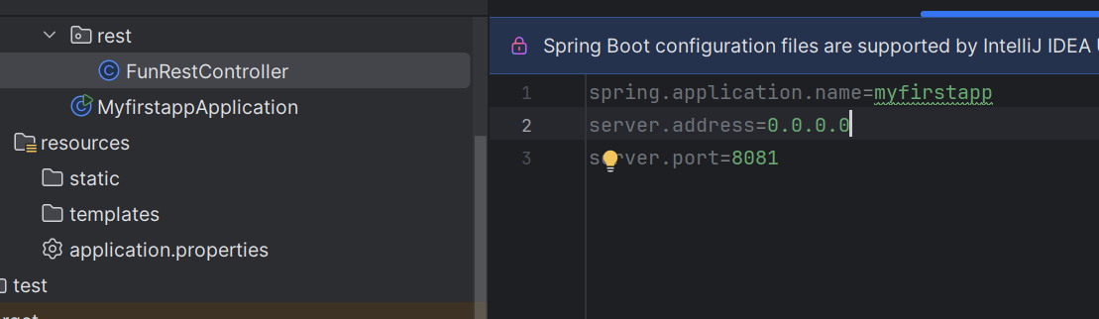

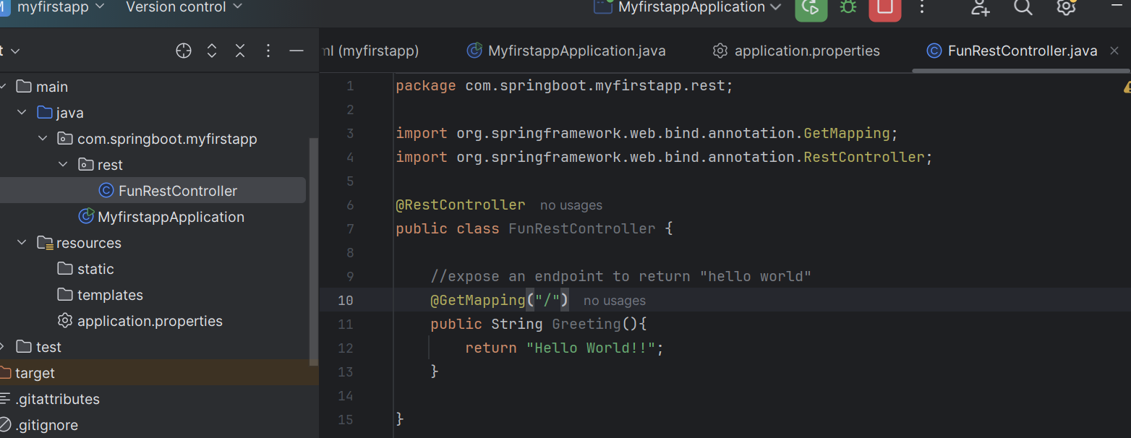

Check at :

[127.0.0.1:8081](http://127.0.0.1:8081/)

**MAVEN FILES**

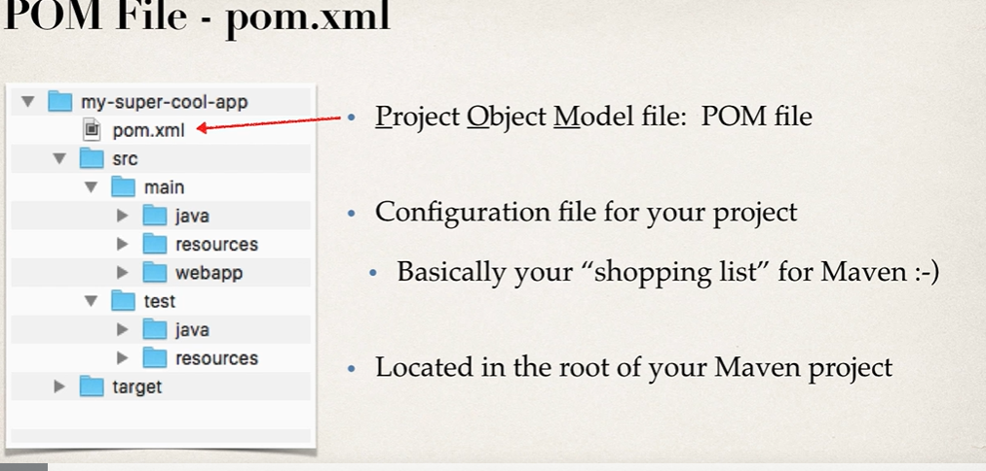

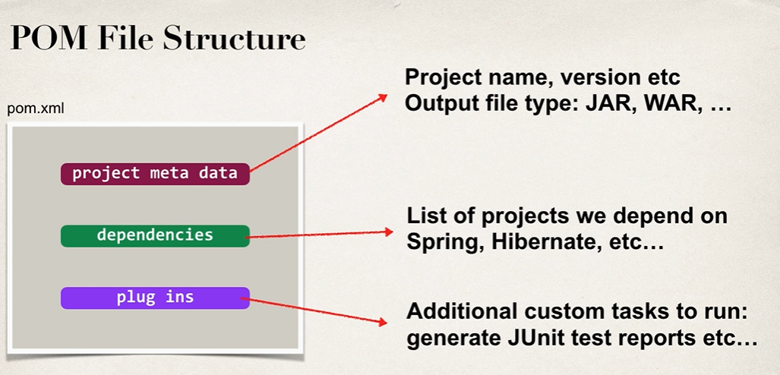

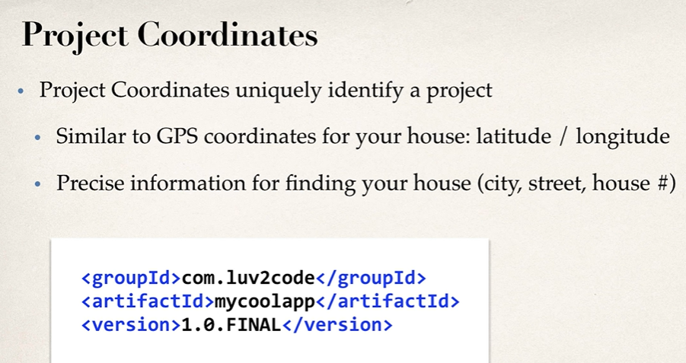

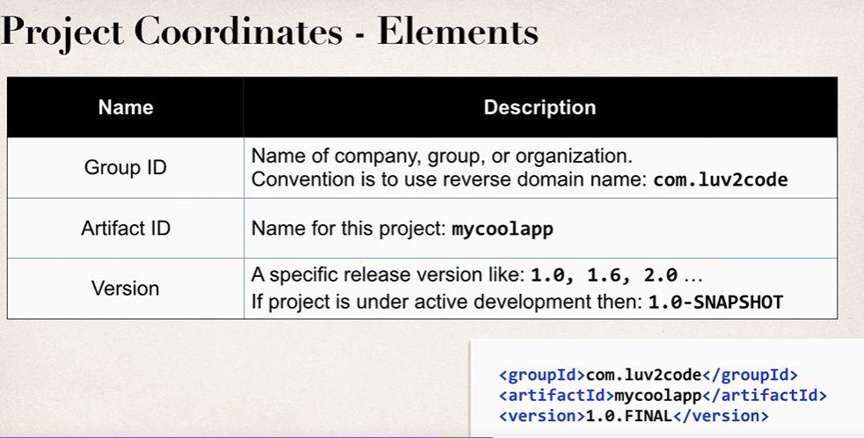

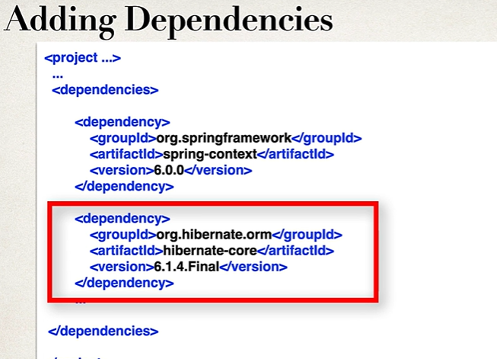

Maven will automatically download theses dependencies.

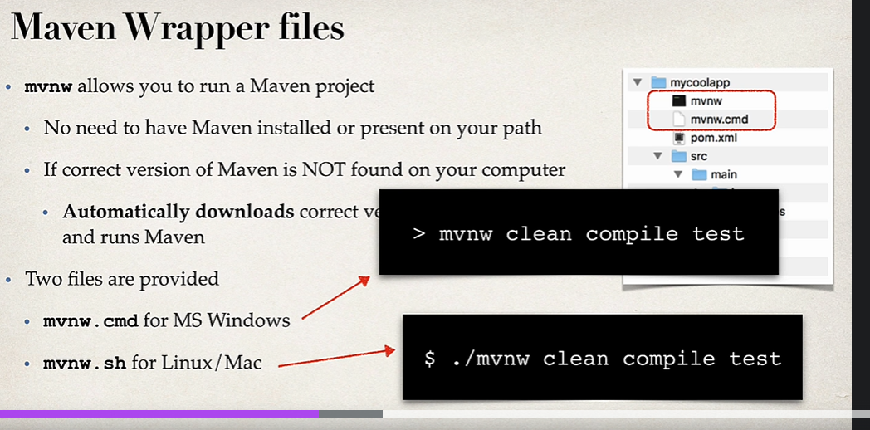

In pom.xml

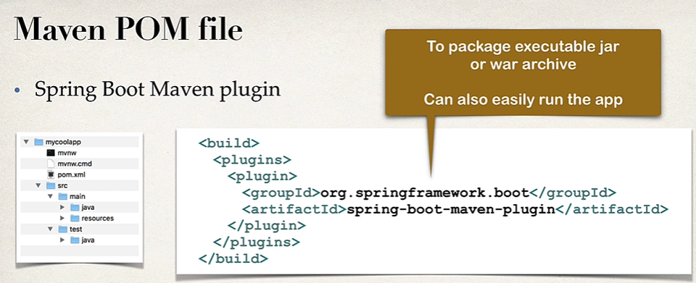

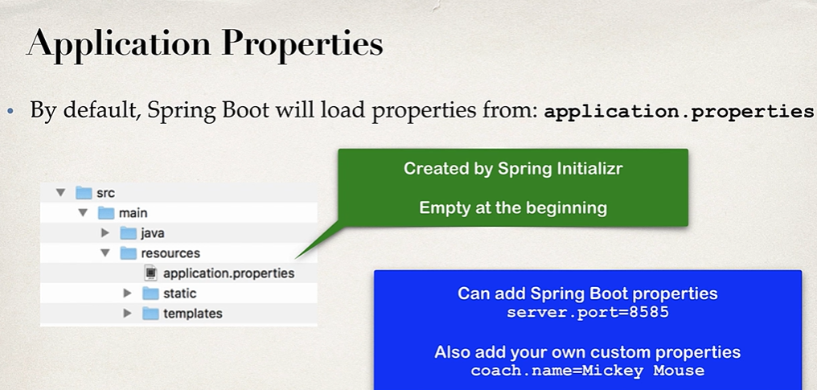

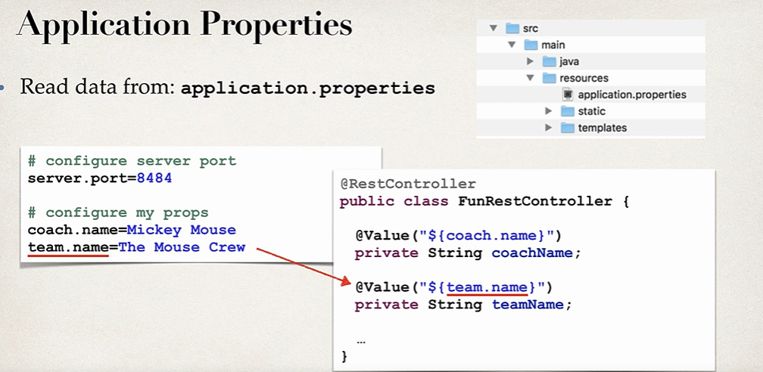

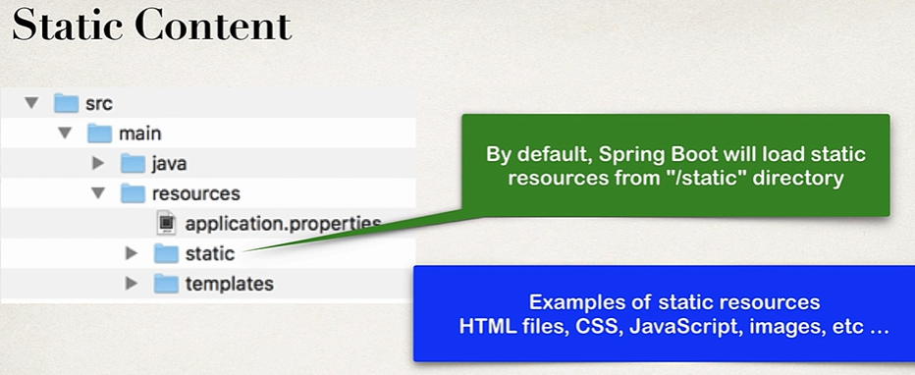

A **REST API** (Representational State Transfer Application Programming Interface) is a set of rules and conventions for building and interacting with web services. REST APIs are commonly used to enable communication between systems over the internet, using standard HTTP protocols.

Each API call is independent, and the server does not store any information about previous requests. This makes the system scalable and easy to maintain.

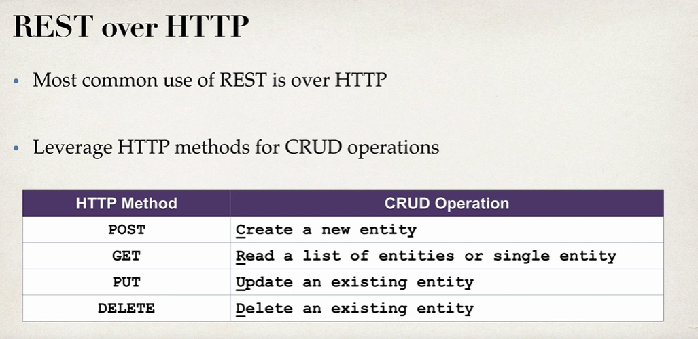

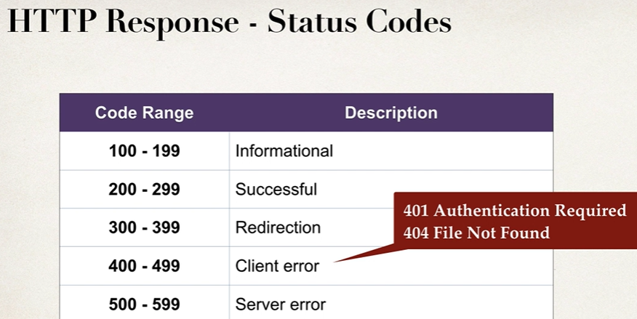

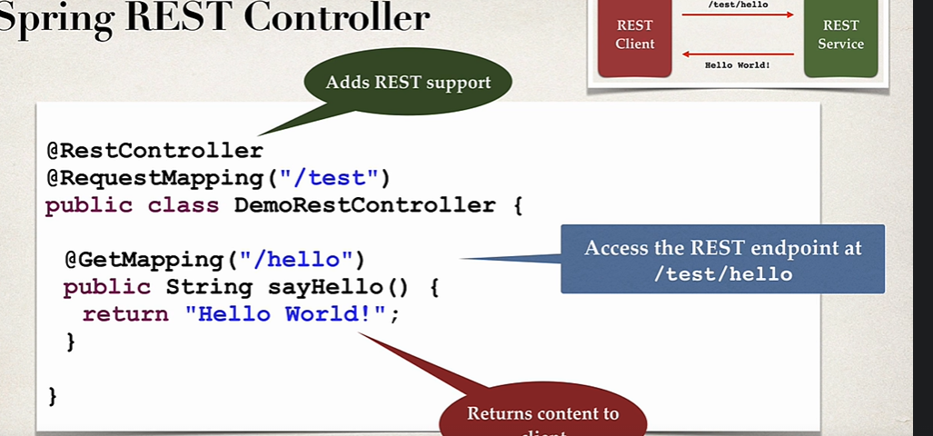

| **Aspect** | **Path Variable** | **Request Body** |
| --- | --- | --- |
| **Location** | Part of the URL path | HTTP request payload/body |
| **Use Case** | Identifies a specific resource | Sends detailed or structured data |
| **Annotation in Spring** | @PathVariable | @RequestBody |
| **Data Type** | Simple (e.g., IDs, strings) | Complex (e.g., JSON objects) |
| **HTTP Methods** | Typically used with GET, DELETE, PUT | Typically used with POST, PUT |

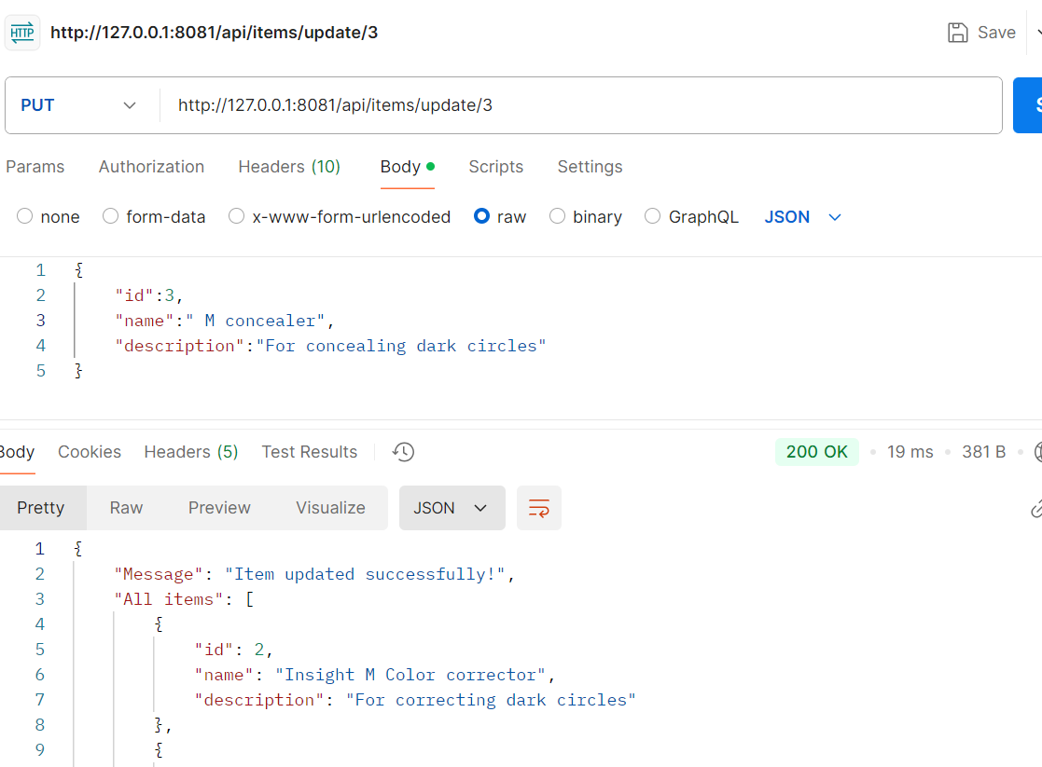s